STANDING WAVES
Objective: To demonstrate the effect of different types of termination.
- Line terminated in characteristics impedance (Matched termination)
- Line terminated in short
- Line terminated in an open

List of Equipment:
- Transmission Line Demonstrator (TLD)
- Sine-wave generator
- Load
- Oscilloscope (CRO)

Theory:
In the microwave frequency region, power is considered to be in electric and magnetic fields that are guided from place to place by some physical structure. Any physical structure that will guide an electromagnetic wave place to place is called a Transmission Line. At low frequencies, the circuit elements are lumped since voltage and current waves affect the entire circuit at the same time. At microwave frequencies the circuit must be broken down into unit sections within which the circuit elements are considered to be lumped.
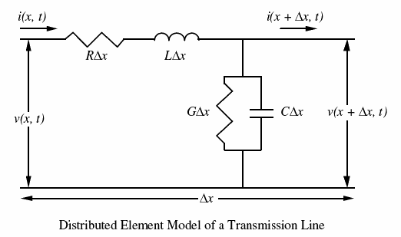
Figure 1
L, R are the distributed inductance and resistance (per unit length) of the conductor.
C, G are the distributed capacitance and conductance (per unit length) of the dielectric between the conductors.
Relation between instantaneous voltage v and current i at any point along the line
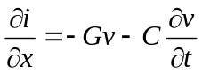 (1)
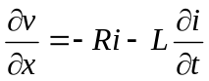 (2)
phasors of voltage V and current I
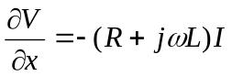 (3)
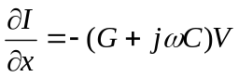 (4)
The propagation constant, γ is a complex number and given by
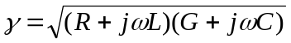 (5)
= 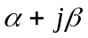 (6)
α is the attenuation constant, β is the phase constant.
The general solutions of the second-order, linear differential equation for V, I are:
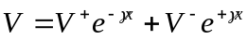 (7)
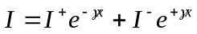 (8)
V⁺, V⁻, I⁺, I⁻ are constants (complex phasors). The terms containing e^{-γx} represent waves travelling in +z direction, terms containing e^{+γx} represent waves travelling in -z direction.
Since
e^{-γx} = e^{-αx} e^{-jβx} (9)
α determines the attenuation along the line, and β determines the phase shift along the line. Characteristics impedance Z₀ is given by
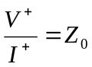 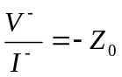 (10)
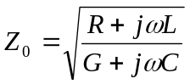 (11)
Consider a transmission line of length l terminated by an arbitrary impedance Z_{L}. At the load z = 0, the voltage and current phasors can be written as:
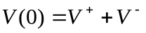 (12)
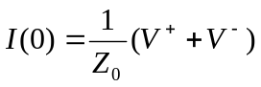 (13)
Load impedance Z_{L}=V(0)/I(0), so we can express the ratio of the backward to forward voltages as:
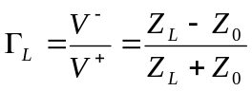 (14)
Γ_{L} is called the load reflection coefficient if we consider V⁺ as the incident wave and V⁻as the reflected wave.
Line terminated in its characteristic impedance: If the end of the transmission line is terminated in a resistor equal in value to the characteristic impedance of the line as calculated by eqn 14, then the voltage and current are compatible. All the power sent down the line is absorbed at the termination and no reflections occur.
Line terminated in a short: When the end of the transmission line is terminated in a short (R_{L} = 0), the voltage at the short must be equal to the product of the current and the resistance. The value of reflection coefficient is -1 as calculated by eqn 14 and standing wave will be formed.
Line terminated in an open: When the line is terminated in an open, the resistance between the open ends of the line must be infinite. Thus the current at the open end is zero. The value of reflection coefficient is 1 as calculated by eqn 14 and standing wave will be obtained.

Procedure:
Travelling wave
  - Click the “Run continuously” button to run the experiment.
  - Source is connected to transmission line demonstrator as shown in figure 2.
  - Change the frequency of the source by slider and amplitude by using knob given in Source window.
  - “Delay Time” is an option for delay, given in Transmission line demonstrator window.
  - By changing the frequency we can change the electrical length of transmission line. It can be easily seen that the wave is absorbed completely at the end. Hence no reflected wave is there.

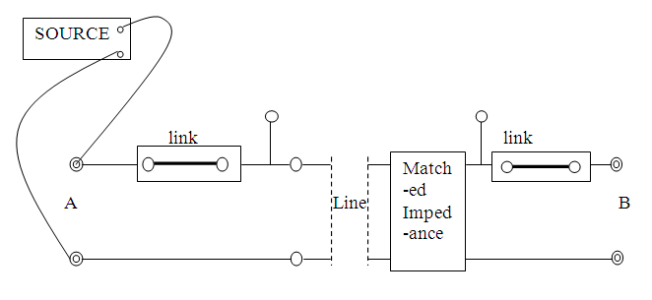
Figure 2. The line terminated in its characteristics impedance

Standing wave (Open Circuit)
- Click the “Run continuously” button to run the experiment.
- Source is connected to transmission line demonstrator as shown in figure 3.
- Change the frequency of the source by slider and amplitude by using knob given in Source window. “Delay Time” is an option for delay, given in Transmission line demonstrator window.
- The maxima can be obtained at both end of line. In case of line terminated in an open no resistance is put in the given terminal as shown in figure 3.

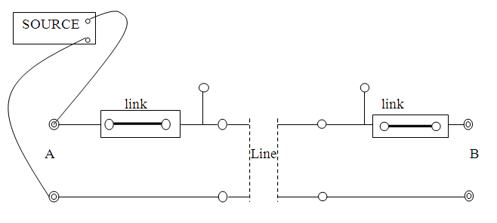
Figure 3. The line terminated in an open

Standing wave (Short Circuit)
- Click the “Run continuously” button to run the experiment.
- Source is connected to transmission line demonstrator as shown in figure 4.
- Change the frequency of the source by slider and amplitude by using knob given in Source window. “Delay Time” is an option for delay, given in Transmission line demonstrator window.
- A short circuit is used to obtain a standing wave pattern in case of line terminated in short as shown in figure 4. In both end of line we will get minima.
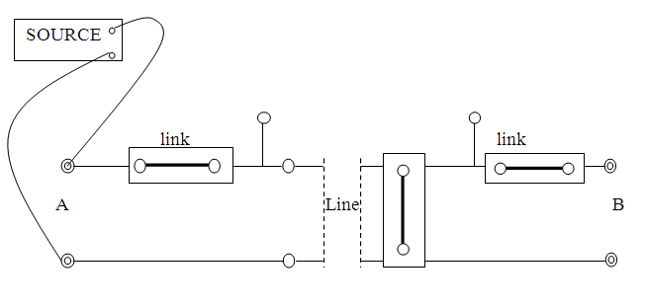
Figure 4. The line terminated in a short

Discussions:
- What will happen if we apply a load different form matched?
- Why the reflections occur if the line is terminated in an open?
- How do you explain the maximum amplitude in terms of the reflection coefficient found previously?

References:
- E.C. Jordan and K.G.Balmain, ‘Electromagnetic wave Radiating Systems’ 1968.
- A.W. Cross, ‘Experimental Microwaves’, 1977.
- Mathew N. O. Sadiku, “Elements of Electromagnetics”, Oxford University Press, 2001.

